

A Project Report on

EMPLOYEE SKILL TRACKING SYSTEM

Submitted in partial fulfillment of requirements for the award of the course of

CGB1221-DATABASE MANAGEMENT SYSTEMS
Under the guidance of

Mrs. P. PRIYA M.E.,

Assistant Professor / CSE

Submitted By

MYDHELINGAM T (927623BCS065)

DEPARTMENT OF COMPUTER SCIENCE AND ENGINEERING

M.KUMARASAMY COLLEGE OF ENGINEERING
(Autonomous)

KARUR – 639 113
MAY 2025

M. KUMARASAMY COLLEGE OF ENGINEERING
(Autonomous Institution affiliated to Anna University, Chennai)

KARUR – 639 113

BONAFIDE CERTIFICATE

This is to certify that this project report on “BLOOD DONATION MANAGEMENT SYSTEM” is the bonafide work of MYDHELINGAM T(927623BCS065) who carried out the project work during the academic year 2024 - 2025 under my supervision.

Signature | Signature
Mrs. P. PRIYA M.E., | Dr. D. PRADEEP M.E.,Ph.D.,
SUPERVISOR, | HEAD OF THE DEPARTMENT,
Department of Computer Science and Engineering, | Department of Computer Science and Engineering,
M. Kumarasamy College of Engineering, | M. Kumarasamy College of Engineering,
Thalavapalayam, Karur -639 113. | Thalavapalayam, Karur -639 113.

DEPARTMENT OF COMPUTER SCIENCE AND ENGINEERING VISION OF THE INSTITUTION
To emerge as a leader among the top institutions in the field of technical education

MISSION OF THE INSTITUTION

- Produce smart technocrats with empirical knowledge who can surmount the global challenges
- Create a diverse, fully-engaged, learner-centric campus environment to provide quality education to the students
- Maintain mutually beneficial partnerships with our alumni, industry, and Professional associations

VISION OF THE DEPARTMENT

To achieve education and research excellence in computer Science and Engineering

MISSION OF THE DEPARTMENT
- To excel in academic through effective teaching learning techniques.
- To promote research in the area of computer science and engineering with the focus on innovation.
- To transform students into technically competent professionals with societal and ethical responsibilities.

PROGRAM EDUCATIONAL OBJECTIVES (PEOs)
- PEO1: Graduates will have successful Career in software industries and R&D divisions through continuous learning
- PEO2: Graduates will provide effective solutions for real world problems in the key domain of computer science and engineering and engage in lifelong learning.
- PEO3: Graduates will excel in their profession by being ethically and socially responsible

PROGRAM OUTCOMES (POs)
Engineering students will be able to:
- Engineering knowledge: Apply the knowledge of mathematics, science, engineering fundamentals, and an engineering specialization to the solution of complex engineering problems.
- Problem analysis: Identify, formulate, review research literature, and analyze complex engineering problems reaching substantiated conclusions using first principles of mathematics, natural sciences, and engineering sciences.
- Design/development of solutions: Design solutions for complex engineering problems and design system components or processes that meet the specified needs with appropriate consideration for the public health and safety, and the cultural, societal, and environmental considerations.
- Conduct investigations of complex problems: Use research-based knowledge and research methods including design of experiments, analysis and interpretation of data, and synthesis of the information to provide valid conclusions.
- Modern tool usage: Create, select, and apply appropriate techniques, resources, and modern engineering and IT tools including prediction and modeling to complex engineering activities with an understanding of the limitations.
- The engineer and society: Apply reasoning informed by the contextual knowledge to assess societal, health, safety, legal and cultural issues and the consequent responsibilities relevant to the professional engineering practice.
- Environment and sustainability: Understand the impact of the professional engineering solutions in societal and environmental contexts, and demonstrate the knowledge of, and need for sustainable development.
- Ethics: Apply ethical principles and commit to professional ethics and responsibilities and norms of the engineering practice.
- Individual and team work: Function effectively as an individual, and as a member or leader in diverse teams, and in multidisciplinary settings.
- Communication: Communicate effectively on complex engineering activities with the engineering community and with society at large, such as, being able to comprehend and write effective reports and design documentation, make effective presentations, give and receive clear instructions.

- Project management and finance: Demonstrate knowledge and understanding of the engineering and management principles and apply these to one’s own work, as a member and leader in a team, to manage projects and in multidisciplinary environments.
- Life-long learning: Recognize the need for, and have the preparation and ability to engage in independent and life-long learning in the broadest context of technological change.
PROGRAM SPECIFIC OUTCOMES (PSOs)
  - PSO1: Professional Skills: Ability to apply the knowledge of computing techniques to design and develop computerized solutions for the problems.
  - PSO2: Successful career: Ability to utilize the computing skills and ethical values in creating a successful career.

ABSTRACT

The Blood Donation Management System (BDMS) is designed to streamline the process of managing blood donations and inventories in blood banks, hospitals, and donation centers by leveraging database management system (DBMS) concepts. Traditional methods of blood donation record-keeping are often inefficient, error-prone, and time-consuming, making it difficult to track donor details, blood availability, and requests in real-time. This system provides a structured and automated approach to managing blood donor registrations, blood group inventories, donation histories, and recipient requests. It includes features such as real-time blood stock tracking, donor eligibility verification, automated notifications for donation reminders, and emergency alerts for critical blood shortages.
.

ABSTRACT WITH POs AND PSOs MAPPING

ABSTRACT | COs  MAPPED | POs  MAPPED | PSOs  MAPPED
The Blood Donation Management System (BDMS) is designed to streamline the process of managing blood donations and inventories in blood banks, hospitals, and donation centers by leveraging database management system (DBMS) concepts. Traditional methods of blood donation record-keeping are often inefficient, error-prone, and time-consuming, making it difficult to track donor details, blood availability, and requests in real-time. This system provides a structured and automated approach to managing blood donor registrations, blood group inventories, donation histories, and recipient requests. It includes features such as real-time blood stock tracking, donor eligibility verification, automated notifications for donation reminders, and emergency alerts for critical blood shortages. | CO1 CO2 CO3 | PO1 PO2 PO3 PO5 PO6 PO8 PO9 PO10 PO11 PO12 | PSO1 PSO2
Note: 1- Low, 2-Medium, 3- HighPO2

SUPERVISOR HEAD OF THE DEPARTMENT

TABLE OF CONTENTS

CHAPTER  No. | TITLE | PAGE  No.
 | ABSTRACT | vii
1 | INTRODUCTION | 1
 | 1.1 PROBLEM STATEMENT | 1
 | 1.2 INTRODUCTION | 1
 | 1.3 DBMS | 2
 | 1.4 PHP | 2
 | 1.5 OBJECTIVE | 2
2 | PROJECT METHODOLOGY & DESIGN | 2
 | 2.1 PROPOSED WORK | 3
 | 2.2 ARCHITECTURE | 4
 | 2.3 E-R DIAGRAM | 5
 | 2.4 SCHEMA DIAGRAM | 6
3 | SOFTWARE REQUIREMENTS | 7
 | 3.1 FRONT END | 7
 | 3.2 BACK END | 7
4 | MODULE DESCRIPTION | 8
 | 4.1 User Management Module | 8
 | 4.2 Donor Management Module | 8
 | 4.3 Blood Request Module | 8
 | 4.4 Blood Group Inventory Module | 9
 | 4.5 Search & Matching Module | 9
5 | IMPLEMENTATION | 10
 | 5.1 CODE | 10
6 | SNAPSHOTS | 14
 | CONCLUSION | 17
 | REFERENCES | 17

INTRODUCTION

PROBLEM STATEMENT

Design and develop a Blood Donation Management System using DBMS concepts to efficiently manage blood donations and donor information. The system should allow donors to register, schedule donation appointments, and track their donation history. It should also allow blood banks to manage inventory levels, monitor blood type availability, and issue blood to hospitals as needed. The database will store and manage critical information such as donor details (name, contact information, blood type), donation records, and blood inventory data.

INTRODUCTION

Blood donation plays a crucial role in healthcare by ensuring the availability of blood for patients in need, including accident victims, surgical patients, and individuals with medical conditions requiring transfusions. However, traditional blood management systems often rely on manual record-keeping, which can lead to inefficiencies, errors, and delays in providing blood to those in urgent need. The Blood Donation Management System (BDMS) is developed to address these challenges by leveraging database management system (DBMS) concepts to efficiently store, manage, and retrieve blood donor and recipient information. The system aims to streamline the process of blood donation, storage, and distribution, ensuring that hospitals and blood banks can easily track blood availability and donor records in real-time.

DATABASE MANAGEMENT SYSTEMS
A Database Management System (DBMS) is a software system that enables the creation, management, and manipulation of databases. It allows users to store, retrieve, update, and delete data efficiently while ensuring data integrity, security, and consistency. DBMS provides an interface between the database and the users or applications, allowing structured access to the data using queries. It supports important operations like transaction management, concurrency control, and data backup. Examples of DBMS include MySQL, Oracle, SQL Server, and PostgreSQL.

PHP
PHP (Hypertext Preprocessor) is a widely-used open-source server-side scripting language designed for web development. It is embedded within HTML code and used to create dynamic and interactive web pages. PHP executes on the server and sends the output (usually HTML) to the client’s browser. It can interact with databases like MySQL, making it ideal for building data-driven applications. PHP supports features like form handling, session management, file operations, and authentication. It is platform-independent and compatible with most servers, including Apache and Nginx. PHP is known for its simplicity, flexibility, and strong community support. It powers many popular websites and systems, including WordPress and Facebook.

OBJECTIVE

The Blood Donation Management System is designed to streamline and simplify the process of donating and requesting blood. Its primary objective is to provide a user-friendly digital platform where individuals can register as donors by entering their personal details such as name, age, blood group, and phone number. The system ensures proper validation of data to maintain accuracy and reliability. Users in need of blood can search for donors by selecting a specific blood group, and the system displays matching donor details for quick access. This reduces the manual workload and enhances the speed of finding suitable donors in emergencies. A thank-you screen acknowledges successful donor registration, adding a touch of appreciation. The platform focuses on accessibility, efficiency, and accurate record management, aiming to improve the overall effectiveness of blood donation services.

PROJECT METHODOLOGY

PROPOSED WORK

Interface :
Donor Dashboard (Register Donor Details, Validate Age & Phone, Submit Blood Donation)
Recipient Dashboard (Search Donors by Blood Group, View Donor Contact Info)
Admin Dashboard (Manage Donors, View Donation Logs, Generate Reports)
Real-time Search & Matching (Instant Filter Based on Selected Blood Group)
User-Friendly Interface (Responsive Layout with Tailwind CSS and Background Visuals)

APPLICATION:
User Registration & Validation (Donor & Recipient Input Validation)
Donor & Blood Request Management (Add, Search, Match, and Display Donor Info)
Eligibility Check Logic (Minimum Age, Valid Phone, Unique Entry)
Communication with Database Layer (CRUD Operations via PHP/SQL)
Alert & Response Handling (No Match Found, Thank You Page, Redirection

DATABASE :
Donors – ( Name, Age, BloodGroup, Phone)
Requests – ( BloodGroupNeeded, RequestDate, Status)
BloodGroups – (GroupName)

  - ARCHITECTURE

INDEX
DETAILS
DATABASE
DONATE
REQUEST
REQUIREMENT
DATABASE

  - E-R DIAGRAM

R-NAME
BLOOD
DONATOR
REQUEST
DONATE FOR
REQUEST FOR
NAME
PHONE
AGE
BLOOD
GROUP
R-AGE
R-PHONE
R-BLOOD
  - SCHEMA DIAGRAM

Donor Table

Name | Age | Blood Group | Phone
MYDHELINGAM | 19 | B+ | 9360739779

CHAPTER 3 SOFTWARE REQUIREMENTS

3.1 Front End

The front-end of the Blood Donation Management System is crafted to offer a clean, modern, and fully responsive user interface using HTML, CSS, and Tailwind CSS. The homepage features a full-screen background image related to healthcare, with a centrally placed, semi-transparent container that uses glassmorphism effects like backdrop-filter and soft shadows to focus user attention. Inside the container, bold, centered headings welcome the user, followed by two vibrant red buttons labeled “Donate Blood” and “Request Blood,” enhanced with smooth hover transitions. Clicking “Donate Blood” navigates to a donor form, which includes fields for name, age, blood group (as a dropdown), and phone number, each validated with real-time error messages and clean, animated focus effects. The form is centered in a soft red-tinted container, keeping visual hierarchy intact. The “Request Blood” interface provides a dropdown to select a blood group, displaying matching donor details below in a responsive, styled table. The “Thank You” screen uses a light green semi-transparent background, with a clear confirmation message and a neatly animated “Back” button to return to the home screen.

3.2 Back End

The back-end of the Blood Donation Management System is developed using PHP and MySQL to ensure secure and efficient data handling. Donor and requester details are collected through web forms and stored in the MySQL database using SQL queries. The system validates input data, such as phone numbers and blood groups, before saving to maintain data integrity. During blood request searches, the back-end queries the database to retrieve matching donor information based on the selected blood group. User sessions are managed securely to handle navigation and maintain state across pages. The database is designed with tables for donors, blood requests, and users to support smooth data operations. PHP scripts handle all CRUD operations and enforce role-based access where needed. Error handling and input validation improve system reliability. This back-end design provides robust data storage and retrieval, supporting real-time blood donation management effectively and securely.

MODULE DESCRIPTION
  - User Management Module

The UI module provides a visually appealing and responsive front-end for the system. It includes pages like the welcome screen, donor registration, blood request, and thank-you confirmation. Designed using HTML, CSS, and Tailwind, it ensures intuitive navigation and user-friendly forms. Clear input fields and buttons guide users through the process with ease. Background images and animations enhance visual engagement. This module ensures a positive and interactive experience for all users.

  - Donor Management Module

This module allows individuals to register as blood donors by submitting details like name, age, blood group, and phone number. Validation ensures only eligible and accurate data is accepted (e.g., age ≥ 16, phone number = 10 digits). Submitted data can be stored or used to display donor lists during requests. The design is simple, clean, and user-friendly. It ensures only valid and reliable donors are listed in the system. This module is crucial for building a verified donor database.

  - Blood Request Module

The blood request module enables users to search for available donors by selecting a required blood group. It filters the donor list in real time and displays matching donor details including name, age, phone, and blood type. The layout uses a searchable dropdown and a styled result table. If no matches are found, a user-friendly message is displayed. This module ensures quick access to potential donors during emergencies. It is essential for the system’s lifesaving functionality.

4.4 Blood Group Inventory Module

The Blood Group Inventory Module is responsible for managing the availability and stock levels of different blood groups in the system. It maintains a dynamic count of each blood type—such as A+, B+, O-, AB+, etc.—based on donations and requests. When a donor registers, the system adds the donated blood group to the inventory. Conversely, when a blood request is made and matched, the corresponding unit is deducted. This ensures real-time monitoring of blood supply and helps in identifying shortages. The module can also generate alerts when specific blood groups fall below critical levels, assisting in proactive donor outreach. This inventory management enhances efficiency, saves time during emergencies, and improves the reliability of the blood donation process.

4.5 Search & Matching Module

The Search & Matching Module plays a critical role in connecting blood seekers with suitable donors. When a user selects a required blood group, this module searches the donor database to find matches based on blood type compatibility. It filters records in real-time to display donor details such as name, age, contact number, and blood group. The matching logic ensures that only active and valid donors are considered, improving the reliability of the system. This feature significantly speeds up the response time during emergencies. Additionally, it provides a user-friendly interface for users to view results in a clear, tabular format. Overall, this module enhances the accessibility and responsiveness of the Blood Donation Management System.

IMPLEMENTATION

INDEX .HTML

<!DOCTYPE html>
<html lang="en">
<head>
<meta charset="UTF-8">
<meta name="viewport" content="width=device-width, initial-scale=1.0">
<title>Blood Donation Management System</title>
<style>
/* CSS Variables for theming */
:root {
--primary-color: #ff0000;
--primary-dark: #cc0000;
--text-color: #333;
--container-bg: rgba(255, 255, 255, 0.6);
--animation-timing: cubic-bezier(0.4, 0, 0.2, 1);
--container-blur: 5px;
--shadow-color: rgba(0, 0, 0, 0.1);
--glow-color: rgba(255, 0, 0, 0.2);
}

/* Dark mode support */
@media (prefers-color-scheme: dark) {
:root {
--text-color: #fff;
--container-bg: rgba(0, 0, 0, 0.6);
--shadow-color: rgba(255, 255, 255, 0.1);
}
}

/* Universal reset */
* {
margin: 0;
padding: 0;
box-sizing: border-box;
}

/* Reduced motion preference */
@media (prefers-reduced-motion: reduce) {
* {
animation-duration: 0.01ms !important;
animation-iteration-count: 1 !important;
transition-duration: 0.01ms !important;
scroll-behavior: auto !important;
}
}

/* Animations */
@keyframes fadeIn {
from {
opacity: 0;
transform: translateY(calc(-20px * var(--direction, 1)));
}
to {
opacity: 1;
transform: translateY(0);
}
}

@keyframes slideIn {
from {
transform: translateX(-100%);
opacity: 0;
}
to {
transform: translateX(0);
opacity: 1;
}
}

@keyframes pulse {
0%, 100% { transform: scale(1); }
50% { transform: scale(1.05); }
}

@keyframes containerGlow {
0%, 100% { box-shadow: 0 0 10px var(--glow-color); }
50% { box-shadow: 0 0 20px var(--glow-color); }
}

/* Base styles */
body {
min-height: 100vh;
min-height: 100dvh;
background-image: url('images/blood-bg.jpg');
background-size: cover;
background-position: center;
background-attachment: fixed;
display: grid;
place-items: center;
font-family: system-ui, -apple-system, sans-serif;
overflow-x: hidden;
position: relative;
}

/* Container styles */
.container {
background-color: var(--container-bg);
padding: clamp(20px, 5vw, 40px);
border-radius: 15px;
text-align: center;
width: min(90%, 600px);
animation:
fadeIn 1s var(--animation-timing),
containerGlow 3s infinite;
backdrop-filter: blur(var(--container-blur));
-webkit-backdrop-filter: blur(var(--container-blur));
box-shadow:
0 0 20px var(--shadow-color),
0 10px 20px -10px var(--shadow-color);
isolation: isolate;
position: relative;
}

/* Container pseudo-elements for decoration */
.container::before,
.container::after {
content: '';
position: absolute;
inset: -2px;
border-radius: 17px;
background: linear-gradient(45deg, var(--primary-color), transparent);
z-index: -1;
opacity: 0.3;
animation: containerGlow 3s infinite alternate;
}

.container::after {
filter: blur(5px);
}

/* Typography */
h1 {
color: var(--text-color);
margin-bottom: clamp(20px, 5vw, 40px);
animation: slideIn 1s var(--animation-timing);
font-size: clamp(1.5rem, 3vw, 2rem);
text-shadow: 2px 2px 4px var(--shadow-color);
line-height: 1.4;
letter-spacing: 0.5px;
}

/* Buttons container */
.buttons-container {
display: flex;
flex-direction: column;
gap: 20px;
animation: fadeIn 1.5s var(--animation-timing);
}

/* Button styles */
.btn {
background-color: var(--primary-color);
color: white;
padding: 20px 40px;
border: none;
border-radius: 10px;
font-size: clamp(1rem, 2vw, 1.125rem);
text-decoration: none;
width: 100%;
max-width: 200px;
margin: 0 auto;
position: relative;
overflow: hidden;
transition: all 0.3s var(--animation-timing);
box-shadow: 0 4px 15px var(--glow-color);
}

/* Button hover effects */
.btn:hover,
.btn:focus-visible {
background-color: var(--primary-dark);
transform: translateY(-2px);
box-shadow:
0 6px 20px var(--glow-color),
0 0 0 2px var(--primary-color);
animation: pulse 1s infinite;
}

/* Button focus styles for accessibility */
.btn:focus-visible {
outline: none;
box-shadow:
0 0 0 3px white,
0 0 0 6px var(--primary-color);
}

/* Button shine effect */
.btn::after {
content: '';
position: absolute;
top: -50%;
left: -50%;
width: 200%;
height: 200%;
background: linear-gradient(
45deg,
transparent,
rgba(255, 255, 255, 0.2),
transparent
);
transform: rotate(45deg);
transition: 0.5s var(--animation-timing);
opacity: 0;
}

.btn:hover::after {
opacity: 1;
transform: rotate(45deg) translate(50%, 50%);
}

/* Individual button animations */
#donate-btn {
--direction: 1;
animation: fadeIn 1.5s var(--animation-timing) backwards;
}

#request-btn {
--direction: 1;
animation: fadeIn 2s var(--animation-timing) backwards;
}

/* Responsive design */
@media (max-width: 480px) {
.container {
padding: 20px;
}

.btn {
padding: 15px 30px;
}
}

/* High contrast mode support */
@media (forced-colors: active) {
.btn {
border: 2px solid ButtonText;
}
.btn:focus-visible {
outline: 2px solid ButtonText;
}
}

/* Print styles */
@media print {
body {
background: none;
}
.container {
box-shadow: none;
border: 1px solid #000;
}
.btn {
border: 1px solid #000;
color: #000;
}
}
</style>
</head>
<body>
<div class="container">
<h1>WELCOME TO BLOOD DONATION MANAGEMENT SYSTEM</h1>
<div class="buttons-container">
<a href="donate.php" class="btn" id="donate-btn" role="button">DONATE BLOOD</a>
<a href="request.php" class="btn" id="request-btn" role="button">REQUEST BLOOD</a>
</div>
</div>
</body>
</html>

LOGIN.PHP

<?php
require_once 'config.php';

if ($_SERVER["REQUEST_METHOD"] == "POST") {
$name = $_POST['name'];
$age = $_POST['age'];
$blood_group = $_POST['blood_group'];
$phone = $_POST['phone'];

// Check if exact combination already exists
$check_sql = "SELECT * FROM donors WHERE name = ? AND age = ? AND blood_group = ? AND phone = ?";
$check_stmt = $conn->prepare($check_sql);
$check_stmt->bind_param("siss", $name, $age, $blood_group, $phone);
$check_stmt->execute();
$result = $check_stmt->get_result();

if ($result->num_rows > 0) {
$error = "This exact donor record already exists!";
} else {
// Insert new donor
$sql = "INSERT INTO donors (name, age, blood_group, phone) VALUES (?, ?, ?, ?)";
$stmt = $conn->prepare($sql);
$stmt->bind_param("siss", $name, $age, $blood_group, $phone);

if ($stmt->execute()) {
header("Location: thanks.php");
exit();
} else {
$error = "Error registering donor";
}
$stmt->close();
}
$check_stmt->close();
}
?>
<!DOCTYPE html>
<html lang="en">
<head>
<meta charset="UTF-8">
<meta name="viewport" content="width=device-width, initial-scale=1.0">
<title>Donor Registration</title>
<style>
:root {
--primary-color: #ff0000;
--primary-dark: #cc0000;
--text-color: #333;
--container-bg: rgba(255, 255, 255, 0.6);
--animation-timing: cubic-bezier(0.4, 0, 0.2, 1);
--container-blur: 5px;
--shadow-color: rgba(0, 0, 0, 0.1);
--glow-color: rgba(255, 0, 0, 0.2);
--input-bg: rgba(255, 255, 255, 0.9);
--error-color: #ff0000;
--error-bg: rgba(255, 0, 0, 0.1);
}

@media (prefers-color-scheme: dark) {
:root {
--text-color: #fff;
--container-bg: rgba(0, 0, 0, 0.6);
--shadow-color: rgba(255, 255, 255, 0.1);
--input-bg: rgba(0, 0, 0, 0.3);
}
}

* {
margin: 0;
padding: 0;
box-sizing: border-box;
}

@media (prefers-reduced-motion: reduce) {
* {
animation-duration: 0.01ms !important;
animation-iteration-count: 1 !important;
transition-duration: 0.01ms !important;
scroll-behavior: auto !important;
}
}

@keyframes fadeIn {
from {
opacity: 0;
transform: translateY(calc(-20px * var(--direction, 1)));
}
to {
opacity: 1;
transform: translateY(0);
}
}

@keyframes slideIn {
from {
transform: translateX(-100%);
opacity: 0;
}
to {
transform: translateX(0);
opacity: 1;
}
}

@keyframes containerGlow {
0%, 100% { box-shadow: 0 0 10px var(--glow-color); }
50% { box-shadow: 0 0 20px var(--glow-color); }
}

@keyframes shake {
0%, 100% { transform: translateX(0); }
25% { transform: translateX(-5px); }
75% { transform: translateX(5px); }
}

body {
min-height: 100vh;
min-height: 100dvh;
background-image: url('images/blood-bg.jpg');
background-size: cover;
background-position: center;
background-attachment: fixed;
display: grid;
place-items: center;
font-family: system-ui, -apple-system, sans-serif;
overflow-x: hidden;
position: relative;
padding: 20px;
}

.container {
background-color: var(--container-bg);
padding: clamp(20px, 5vw, 40px);
border-radius: 15px;
width: min(90%, 500px);
animation: fadeIn 1s var(--animation-timing),
containerGlow 3s infinite;
backdrop-filter: blur(var(--container-blur));
-webkit-backdrop-filter: blur(var(--container-blur));
box-shadow: 0 0 20px var(--shadow-color),
0 10px 20px -10px var(--shadow-color);
isolation: isolate;
position: relative;
}

.container::before,
.container::after {
content: '';
position: absolute;
inset: -2px;
border-radius: 17px;
background: linear-gradient(45deg, var(--primary-color), transparent);
z-index: -1;
opacity: 0.3;
animation: containerGlow 3s infinite alternate;
}

.container::after {
filter: blur(5px);
}

.header-container {
display: flex;
justify-content: space-between;
align-items: center;
margin-bottom: 30px;
position: relative;
width: 100%;
}

.back-btn {
position: absolute;
right: 0;
top: 50%;
transform: translateY(-50%);
padding: 10px 20px;
font-size: 1rem;
text-decoration: none;
background-color: var(--primary-color);
color: white;
border-radius: 8px;
transition: all 0.3s var(--animation-timing);
}

.back-btn:hover,
.back-btn:focus-visible {
background-color: var(--primary-dark);
transform: translateY(calc(-50% - 2px));
box-shadow: 0 6px 20px var(--glow-color),
0 0 0 2px var(--primary-color);
}

.back-btn:focus-visible {
outline: none;
box-shadow: 0 0 0 3px white,
0 0 0 6px var(--primary-color);
}

h1 {
color: var(--text-color);
margin-bottom: 0;
animation: slideIn 1s var(--animation-timing);
font-size: clamp(1.5rem, 3vw, 2rem);
text-shadow: 2px 2px 4px var(--shadow-color);
line-height: 1.4;
letter-spacing: 0.5px;
text-align: center;
width: 100%;
padding-right: 60px;
}

.form-group {
margin-bottom: 20px;
text-align: left;
animation: fadeIn 1s var(--animation-timing);
animation-fill-mode: both;
}

.form-group:nth-child(1) { animation-delay: 0.2s; }
.form-group:nth-child(2) { animation-delay: 0.4s; }
.form-group:nth-child(3) { animation-delay: 0.6s; }
.form-group:nth-child(4) { animation-delay: 0.8s; }

label {
display: block;
margin-bottom: 8px;
color: var(--text-color);
font-weight: 600;
font-size: 0.95rem;
letter-spacing: 0.5px;
}

input, select {
width: 100%;
padding: 12px;
border: 2px solid transparent;
border-radius: 8px;
font-size: 1rem;
transition: all 0.3s var(--animation-timing);
background-color: var(--input-bg);
color: var(--text-color);
}

input:hover, select:hover {
border-color: var(--primary-color);
}

input:focus, select:focus {
outline: none;
border-color: var(--primary-color);
box-shadow: 0 0 0 3px var(--glow-color);
}

input:invalid, select:invalid {
border-color: var(--error-color);
animation: shake 0.3s var(--animation-timing);
}

.btn {
background-color: var(--primary-color);
color: white;
padding: 15px 30px;
border: none;
border-radius: 8px;
font-size: clamp(1rem, 2vw, 1.125rem);
cursor: pointer;
transition: all 0.3s var(--animation-timing);
animation: fadeIn 1s var(--animation-timing);
animation-delay: 1s;
animation-fill-mode: both;
box-shadow: 0 4px 15px var(--glow-color);
width: 100%;
max-width: 200px;
margin: 20px auto 0;
display: block;
position: relative;
overflow: hidden;
}

.btn:hover,
.btn:focus-visible {
background-color: var(--primary-dark);
transform: translateY(-2px);
box-shadow: 0 6px 20px var(--glow-color),
0 0 0 2px var(--primary-color);
}

.btn:focus-visible {
outline: none;
box-shadow: 0 0 0 3px white,
0 0 0 6px var(--primary-color);
}

.btn::after {
content: '';
position: absolute;
top: -50%;
left: -50%;
width: 200%;
height: 200%;
background: linear-gradient(
45deg,
transparent,
rgba(255, 255, 255, 0.2),
transparent
);
transform: rotate(45deg);
transition: 0.5s var(--animation-timing);
opacity: 0;
}

.btn:hover::after {
opacity: 1;
transform: rotate(45deg) translate(50%, 50%);
}

.error {
color: var(--error-color);
margin: 20px 0;
padding: 10px;
border-radius: 8px;
background-color: var(--error-bg);
animation: fadeIn 0.5s var(--animation-timing);
font-weight: 500;
text-align: center;
}

@media (max-width: 480px) {
.container {
padding: 20px;
}

input, select {
font-size: 16px; /* Prevents zoom on mobile */
}
}

@media (forced-colors: active) {
.btn {
border: 2px solid ButtonText;
}
.btn:focus-visible {
outline: 2px solid ButtonText;
}
input, select {
border: 1px solid ButtonText;
}
}

@media print {
body {
background: none;
}
.container {
box-shadow: none;
border: 1px solid #000;
}
.btn {
border: 1px solid #000;
color: #000;
}
input, select {
border: 1px solid #000;
}
}
</style>
</head>
<body>
<div class="container">
<div class="header-container">
<h1>DONOR REGISTRATION</h1>
<a href="index.html" class="back-btn">BACK</a>
</div>
<?php if (isset($error)): ?>
<div class="error" role="alert"><?php echo htmlspecialchars($error); ?></div>
<?php endif; ?>
<form method="POST" action="<?php echo htmlspecialchars($_SERVER["PHP_SELF"]); ?>" onsubmit="return validateForm()">
<div class="form-group">
<label for="name">NAME</label>
<input type="text" id="name" name="name" required
pattern="[A-Za-z\s]+" title="Please enter a valid name (letters and spaces only)">
</div>
<div class="form-group">
<label for="age">AGE</label>
<input type="number" id="age" name="age" min="18" max="65" required
title="Age must be between 18 and 65">
</div>
<div class="form-group">
<label for="blood_group">BLOOD GROUP</label>
<select id="blood_group" name="blood_group" required>
<option value="">Select Blood Group</option>
<option value="A+">A+</option>
<option value="A-">A-</option>
<option value="B+">B+</option>
<option value="B-">B-</option>
<option value="O+">O+</option>
<option value="O-">O-</option>
<option value="AB+">AB+</option>
<option value="AB-">AB-</option>
</select>
</div>
<div class="form-group">
<label for="phone">PHONE</label>
<input type="tel" id="phone" name="phone" pattern="[0-9]{10}" required
title="Please enter a 10-digit phone number">
</div>
<button type="submit" class="btn">REGISTER</button>
</form>
</div>

<script>
function validateForm() {
var phone = document.getElementById('phone').value;
var age = document.getElementById('age').value;
var name = document.getElementById('name').value;

if (!/^[A-Za-z\s]+$/.test(name)) {
alert('Please enter a valid name (letters and spaces only)');
return false;
}

if (phone.length !== 10 || isNaN(phone)) {
alert('Please enter a valid 10-digit phone number');
return false;
}

if (age < 18 || age > 65) {
alert('Age must be between 18 and 65');
return false;
}

return true;
}
</script>
</body>
</html>

Index page

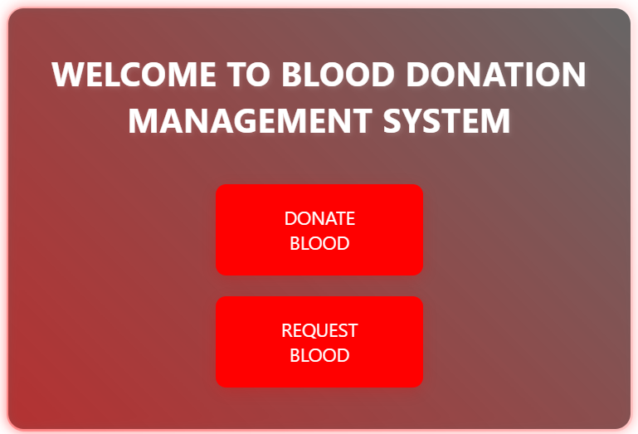

CHAPTER 6 SNAPSHOTS

  - Donor page

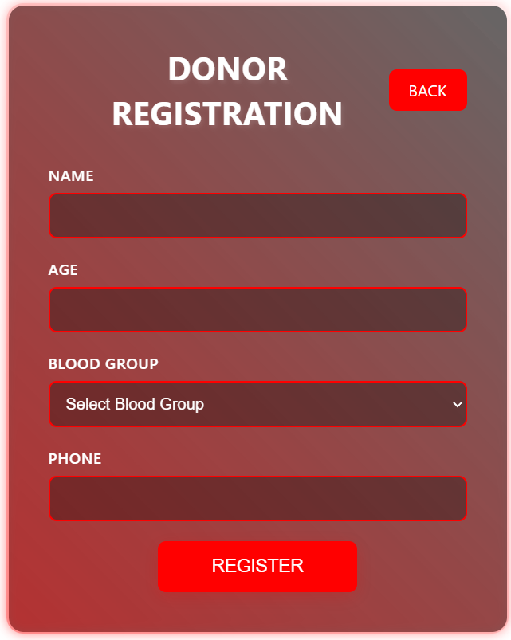

  - Request Page
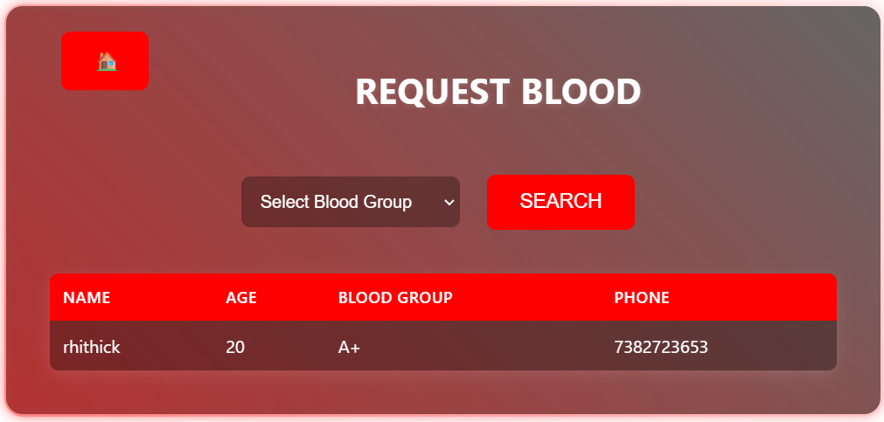
  - Thank you page
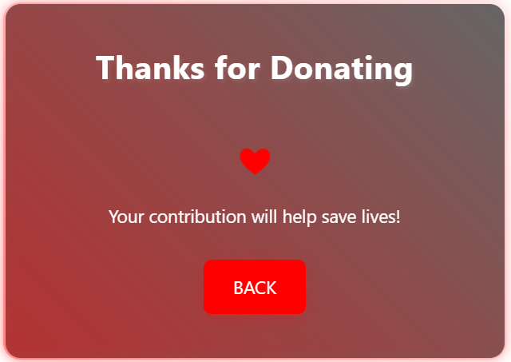



CONCLUSION

The Blood Donation Management System is an efficient and user-friendly platform designed to streamline the process of blood donation and requests. It connects donors and recipients seamlessly, ensuring timely availability of blood when needed. The system improves communication and reduces delays by maintaining accurate donor information and real-time search capabilities. With a secure and robust back-end, data integrity and privacy are prioritized. The intuitive front-end design enhances user experience for both donors and requesters. This project promotes social responsibility by encouraging more people to donate blood. It also assists healthcare providers in managing blood supply effectively. Overall, the system simplifies blood donation management, making it faster, safer, and more reliable. It has the potential to save lives by bridging gaps in the donation process. This project contributes significantly to public health and community welfare.

REFERENCES

1.W3Schools – PHP, MySQL, HTML, CSS and JavaScript Tutorials

https://www.w3schools.com

PHP.net – Official PHP Documentation
https://www.php.net

MySQL Documentation – MySQL Database Server Reference Manual
https://dev.mysql.com/doc/

